World War II
The Homefront

“Total War”
Restrictions | Opportunities

President Roosevelt signs the Selective Service Training Act  Sept. 16, 1940 | Charles Lindbergh speaks at an America First rally  May 21, 1941 | President Roosevelt signs the U.S. Declaration of War Against Japan  December 8, 1941
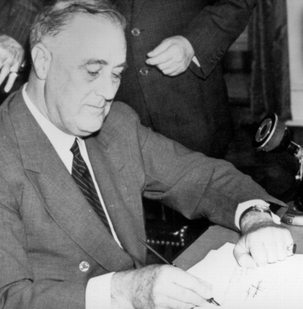 | 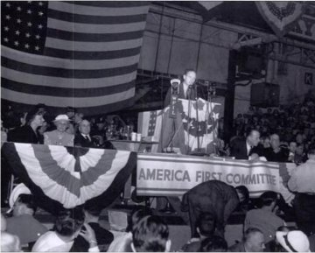 | 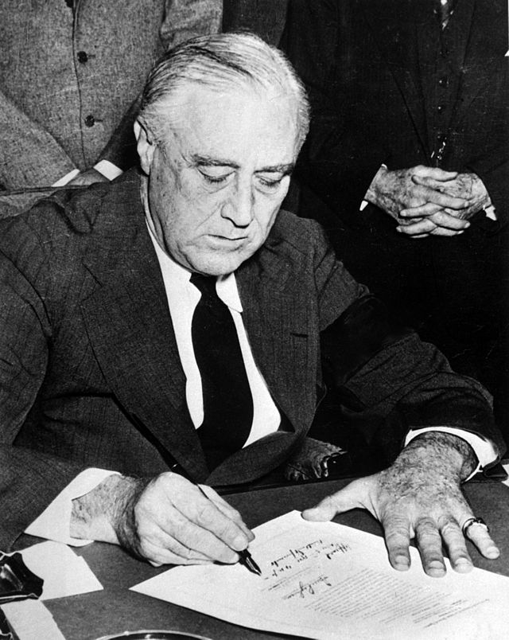
Analysis 1

Gross Domestic Product (GDP)
of Allied and Axis Powers during World War II
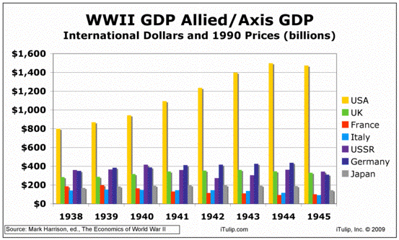
Analysis 2

War Production Board Logo | NLRB Logo | Victory Garden Logo | Propaganda Poster
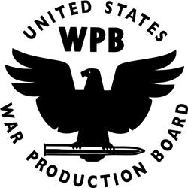 | 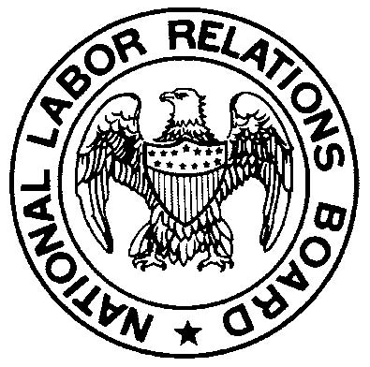 |  | 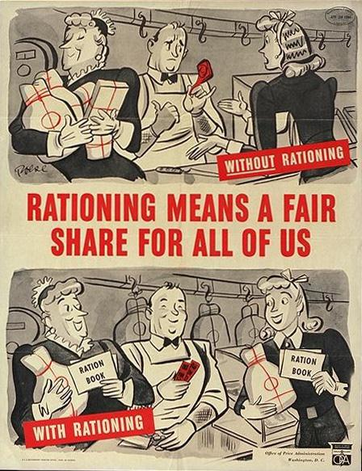
Analysis 3

U.S. War Bond | Tax Rates, 1914-2012
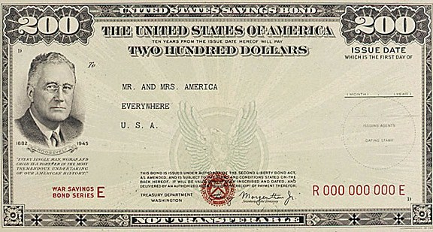 | 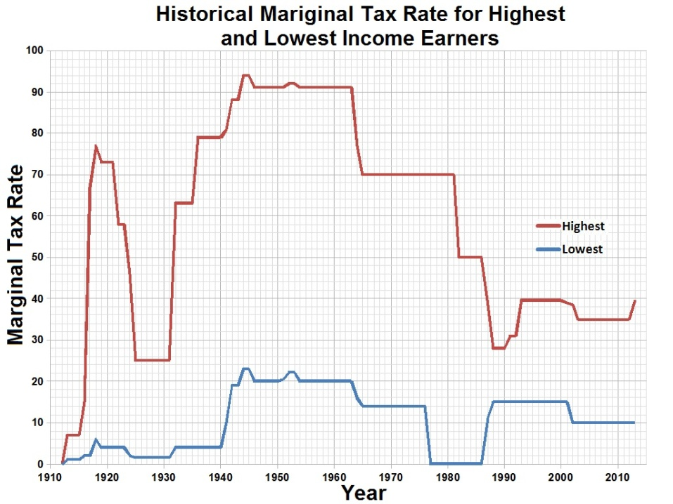
Analysis 4

1939 Chrysler Royal | Chrysler Automobile Plant  1941
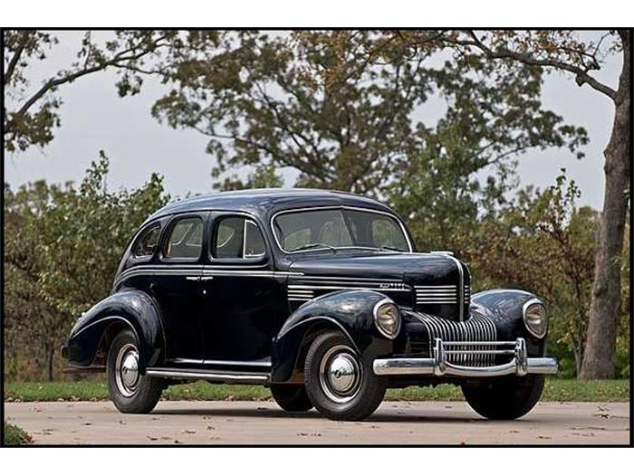 | 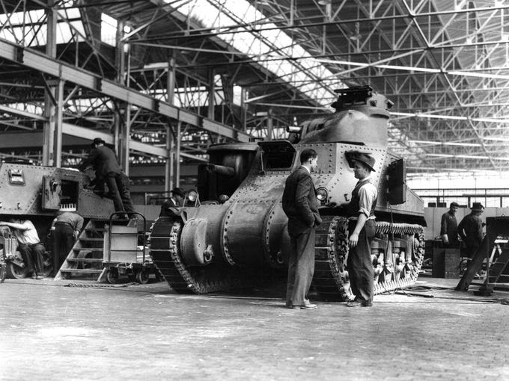
Analysis 5

Comedian Charlie Chaplin in The Great Dictator,  1940 | Film actress Frances Langford at USO Show  Pavuvu, South Pacific, August 7, 1944
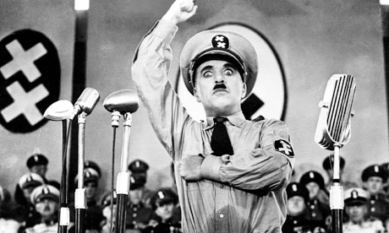 | 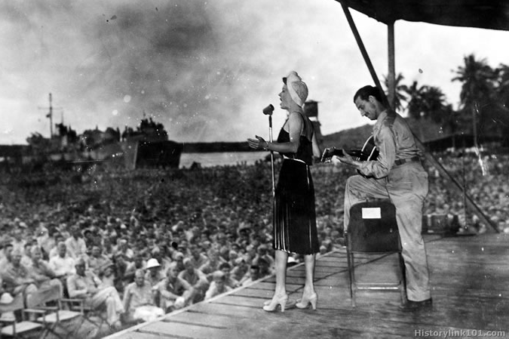
Analysis 6

Propaganda Poster | Office of Censorship pin
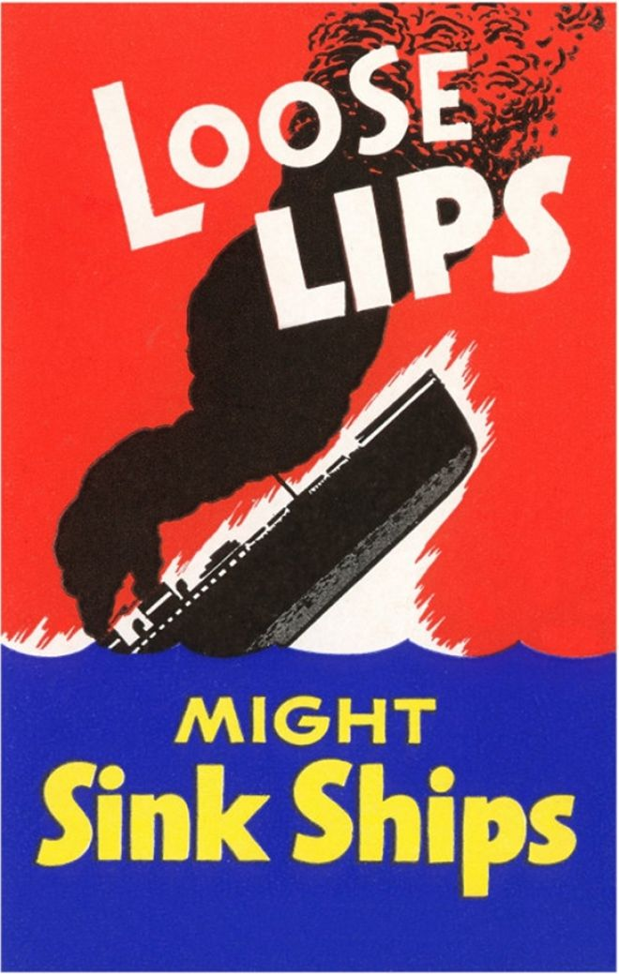 | 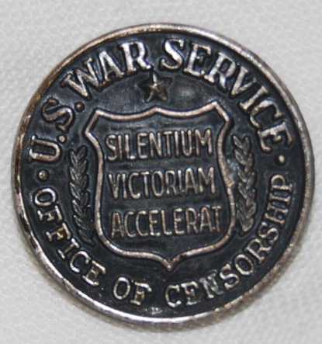
Analysis 7

American POWs captured in Tunisia after their defeat at Kasserine Pass, 1943 | Propaganda Poster  1943 | Propaganda Poster  Early 1940s
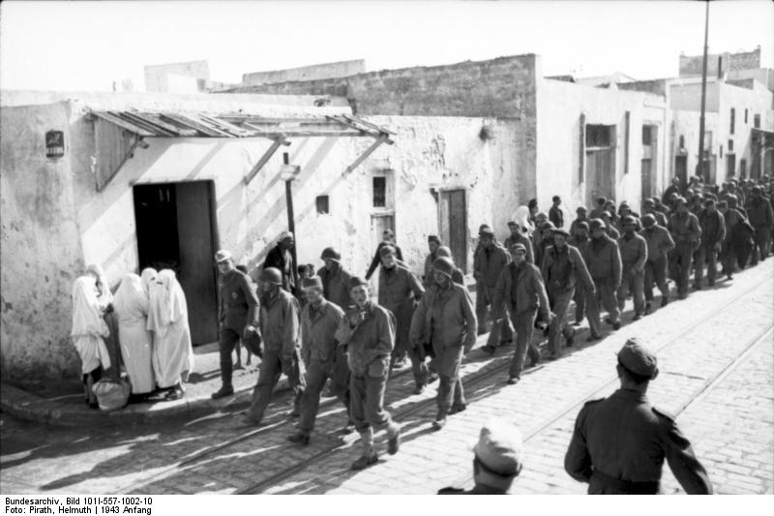 | 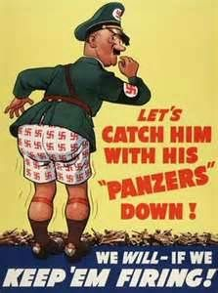 | 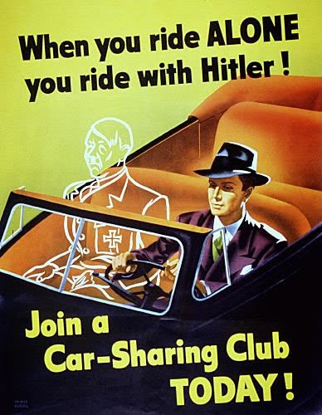
Analysis 8

German Reichstag,  1930s | West Virginia Board of Education v. Barnette  U.S. Supreme Court, 1943
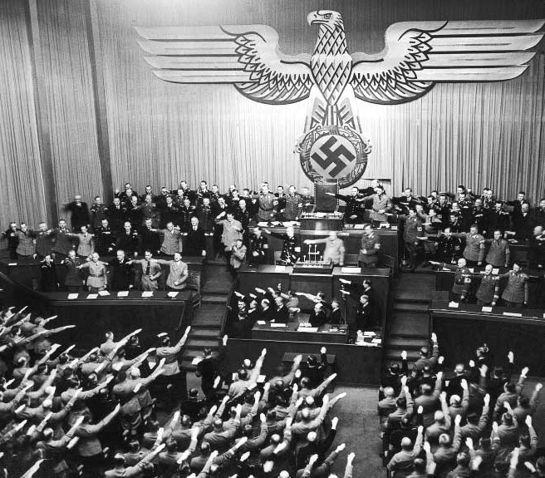 | Background: The West Virginia Board of Education required that the flag salute be part of the program of activities in all public schools. All teachers and pupils were required to honor the Flag; refusal to salute was treated as "insubordination" and was punishable by expulsion and charges of delinquency.  Opinion of the Court: “The case is made difficult not because the principles of its decision are obscure but because the flag involved is our own. Nevertheless, we apply the limitations of the Constitution with no fear that freedom to be intellectually and spiritually diverse or even contrary will disintegrate the social organization. To believe that patriotism will not flourish if patriotic ceremonies are voluntary and spontaneous instead of a compulsory routine is to make an unflattering estimate of the appeal of our institutions to free minds… If there is any fixed star in our constitutional constellation, it is that no official, high or petty, can prescribe what shall be orthodox in politics, nationalism, religion, or other matters of opinion or force citizens to confess by word or act their faith therein. If there are any circumstances which permit an exception, they do not now occur to us. We think the action of the local authorities in compelling the flag salute and pledge transcends constitutional limitations on their power and invades the sphere of intellect and spirit which it is the purpose of the First Amendment to our Constitution to reserve from all official control.”
Analysis 9

Propaganda Poster #1 | Propaganda Poster #2 | Sacramento Bee article  May 7, 1942
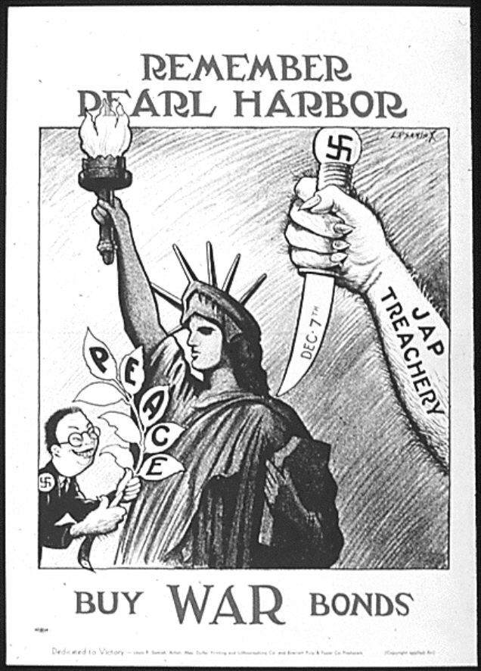 | 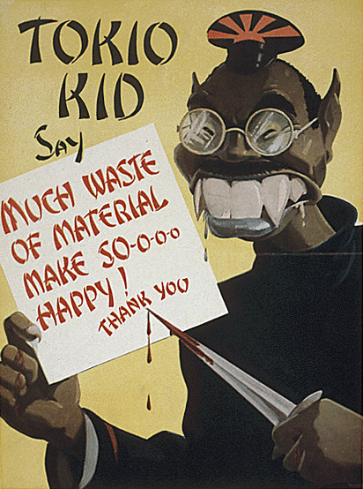 | 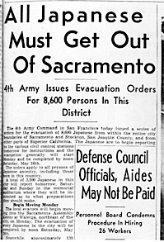
Analysis 10

Korematsu v. United States  U.S. Supreme Court, 1944 | Civil Liberties Act of 1988  Enacted by U.S. Congress, August 10, 1988
Opinion of the Court  “Korematsu was not excluded from the Military Area because of hostility to him or his race. He was excluded because we are at war with the Japanese Empire, because the properly constituted military authorities feared an invasion of our West Coast and felt constrained to take proper security measures, because they decided that the military urgency of the situation demanded that all citizens of Japanese ancestry be segregated from the West Coast temporarily, and, finally, because Congress, reposing its confidence in this time of war in our military leaders — as inevitably it must — determined that they should have the power to do just this.” | “The Congress recognizes that… a grave injustice was done to both citizens and permanent residents of Japanese ancestry by the evacuation, relocation, and internment of civilians during World War II.  “As the Commission documents, these actions were carried out without adequate security reasons and without any acts of espionage or sabotage documented by the Commission, and were motivated largely by racial prejudice, wartime hysteria, and a failure of political leadership.  “The excluded individuals of Japanese ancestry suffered enormous damages, both material and intangible, and there were incalculable losses in education and job training, all of which resulted in significant human suffering for which appropriate compensation has not been made.  “For these fundamental violations of the basic civil liberties and constitutional rights of these individuals of Japanese ancestry, the Congress apologizes on behalf of the Nation.”
Analysis 11

Propaganda Poster  Early 1940s | Mexican Americans wearing “Zoot” Suits  Los Angeles Jail, 1943
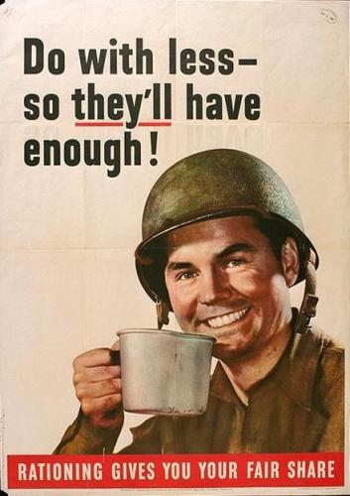 | 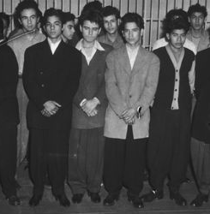
Analysis 12

332nd Fighter Group  “Tuskegee Airmen” |  | 442nd Regimental Combat Team  “Nisei” Regiment
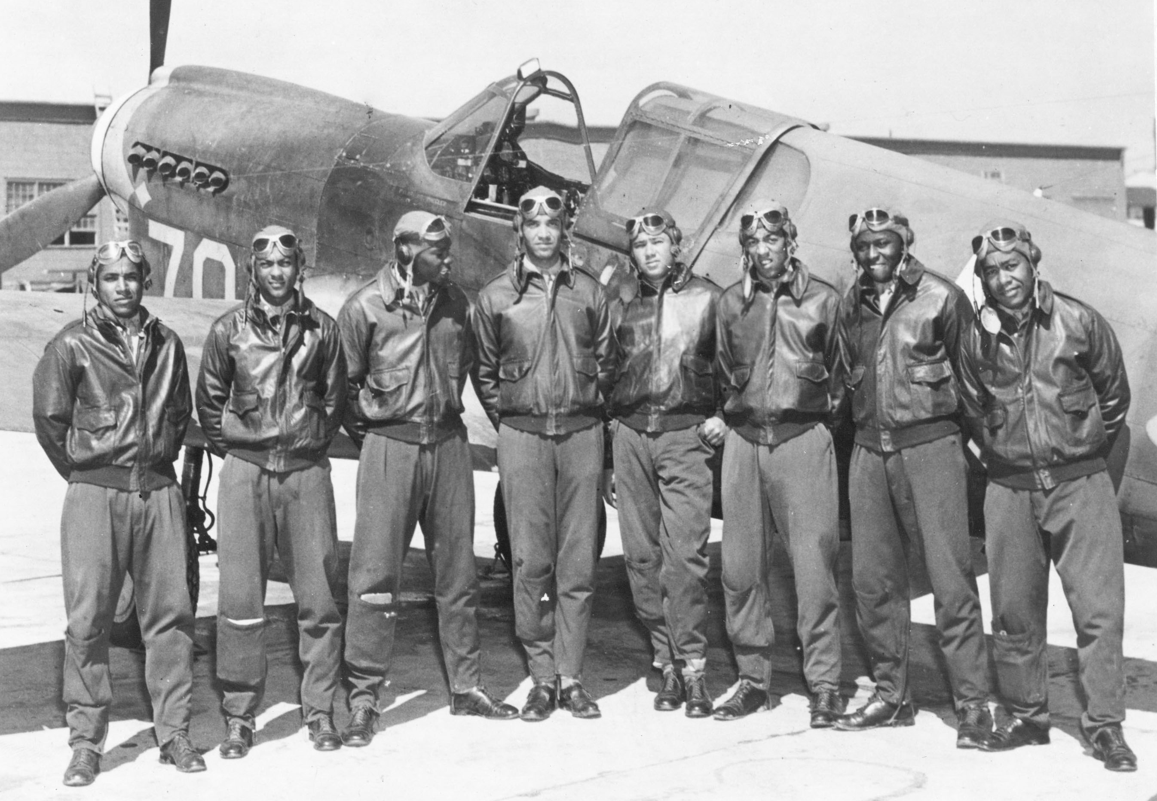 |  | 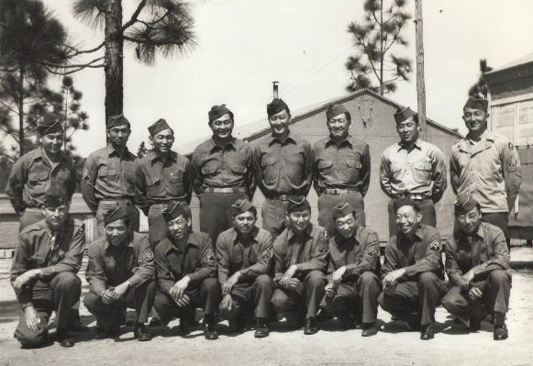
Comanche Code Talkers  Fort Benning, GA |  | Medina Brothers  from Puerto Rico and Brooklyn, NY
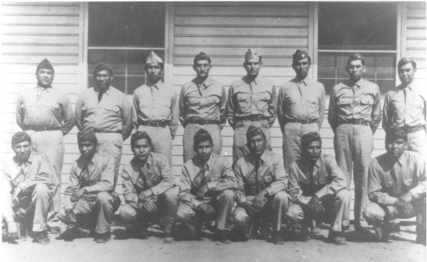 |  | 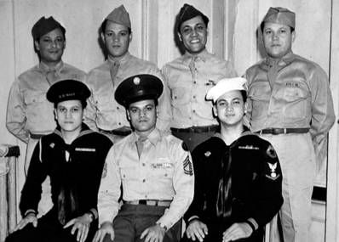
Analysis 13

Propaganda Poster  Early 1940s | African American Migration  1940-1970 |  | Braceros arriving in Los Angeles, 1943
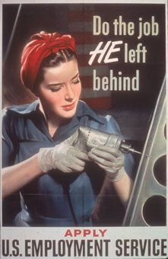 | 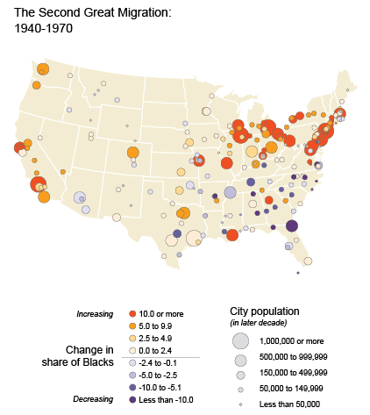 |  | 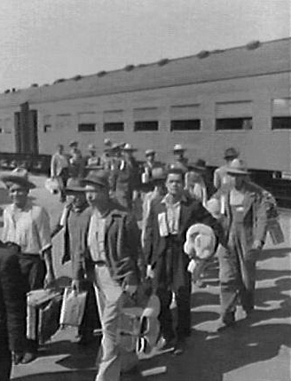
Analysis 14

Nazi Poster promoting “Racial Hygiene,”  1930s | Civil Rights Demonstrators in Philadelphia  Mid-1940s
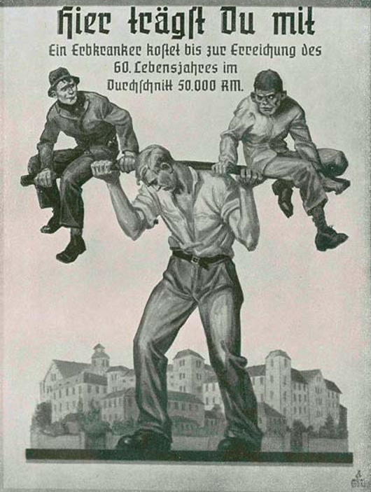 | 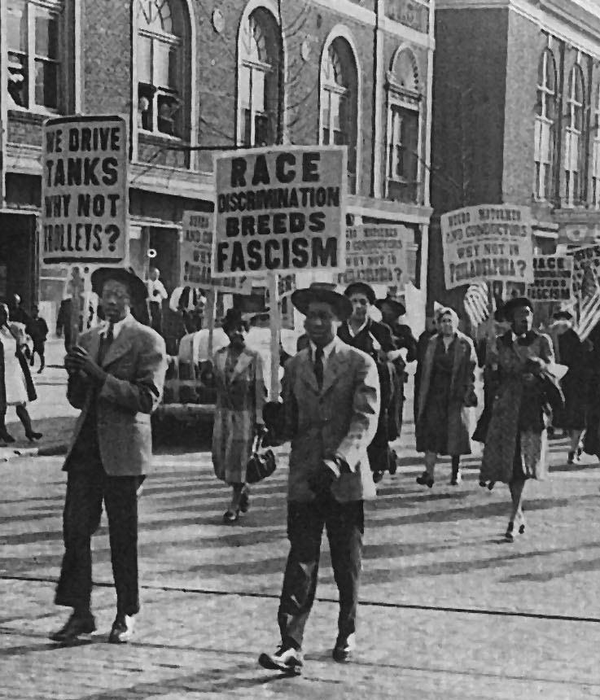
Analysis 15

Analysis 1 | Analysis 6 | Analysis 11
Analysis 2 | Analysis 7 | Analysis 12
Analysis 3 | Analysis 8 | Analysis 13
Analysis 4 | Analysis 9 | Analysis 14
Analysis 5 | Analysis 10 | Analysis 15

