Pre-Columbian America
& Spanish Colonization

Map of Pre-Columbian Indigenous Cultures
 | Shade the locations of the following indigenous cultures. Indicate the color inside the (parentheses) below  ( ) Inca  ( ) Maya  ( ) Aztec  ( ) Anasazi  ( ) Pueblo  ( ) Plains  ( ) Mississippian  ( ) Iroquois Confederacy  Pinpoint on the map and label these centers of major indigenous civilizations  - Tenochtitlan (Aztec Empire)  - Cuzco (Inca Empire)  - Cahokia (Mississippian culture)

Comparing Pre-Columbian Indigenous Cultures
 | Aztec & Inca Empires | Mississippian Culture | Smaller North American Tribes
Location

Food & diet

Population Density:
Compact and sedentary?

or

Scattered and nomadic?

Significant political/religious/economic characteristic

Any other characteristic of your choosing

Why do you think that “Mississippian Culture” is placed the middle column of the chart above?

Christopher Columbus’ Journal
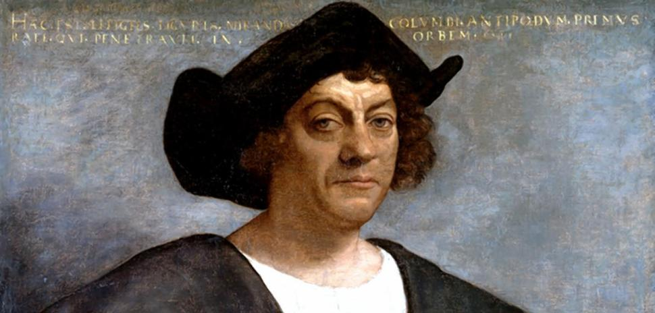
Oct. 12, 1492

"As I saw that [the indigenous people] were very friendly to us, and perceived that they could be much more easily converted to our holy faith by gentle means than by force, I presented them with some red caps, and strings of beads to wear upon the neck, and many other trifles of small value, wherewith they were much delighted, and became wonderfully attached to us. Afterwards they came swimming to the boats, bringing parrots, balls of cotton thread, javelins, and many other things which they exchanged for articles we gave them, such as glass beads, and hawk's bells; which trade was carried on with the utmost good will. But they seemed on the whole to me, to be a very poor people. They all go completely naked, even the women, though I saw but one girl. All whom I saw were young, not above thirty years of age, well made, with fine shapes and faces… Weapons they have none, nor are acquainted with them, for I showed them swords which they grasped by the blades, and cut themselves through ignorance. They have no iron, their javelins being without it, and nothing more than sticks, though some have fish-bones or other things at the ends. They are all of a good size and stature, and handsomely formed. I saw some with scars of wounds upon their bodies, and demanded by signs the of them; they answered me in the same way, that there came people from the other islands in the neighborhood who endeavored to make prisoners of them, and they defended themselves… It appears to me, that the people are ingenious, and would be good servants and I am of opinion that they would very readily become Christians, as they appear to have no religion. They very quickly learn such words as are spoken to them. If it please our Lord, I intend at my return to carry home six of them to your Highnesses, that they may learn our language."
Questions
- What contradictions do you see in Columbus’ impressions of indigenous people?

- How accurate do you think Columbus is in his interpretation of indigenous culture?

- How does Columbus’ attitude affect his future plans for treatment of indigenous people?

Motivations for Portuguese & Spanish Exploration & Colonization
List at three pieces of evidence supporting the idea that these factors drove the Portuguese and Spanish effort for exploration and colonization.
“Gold” | “God” | “Glory”
If you had to choose one single factor, which would you select as the driving force behind exploration and colonization? Why?

Columbian Exchange
Inside the arrows, list five significant trans-Atlantic biological exchanges as a result of Columbus’ voyages and subsequent European colonization.

Map of Early European Colonization
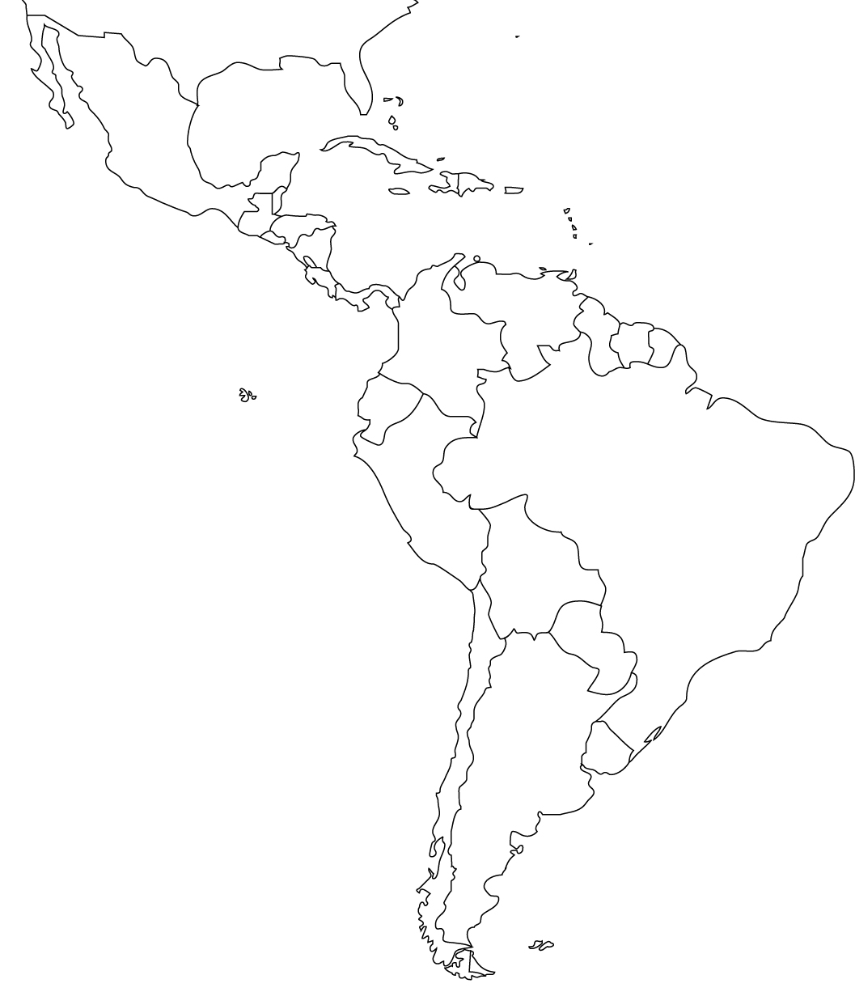 | Shade the locations of the Spanish and Portuguese empires. Indicate the color inside the (parentheses) below.  ( ) Spanish  ( ) Portuguese  Draw a line representing the demarcation between Spanish and Portuguese settlement established by the  Treaty of Tordesillas.  Pinpoint and label the following important colonial settlements  - St. Augustine  - Havana  - Buenos Aires  - Mexico City  - Lima  - Sao Paulo

Spanish Catholics Debate the Treatment of Indigenous People
Bartolome de Las Casas  A Brief Account of the Destruction of the Indies, 1542 | Juan Ginés de Sepúlveda  The Nature of Natives, 1550
…of all the infinite universe of humanity, [indigenous Americans] are the most guileless, the most devoid of wickedness and duplicity, the most obedient and faithful to their native masters and to the Spanish Christians whom they serve. They are by nature the most humble, patient, and peaceable, holding no grudges, free from embroilments, neither excitable nor quarrelsome. These people are the most devoid of rancors, hatreds, or desire for vengeance of any people in the world. And because they are so weak and complaisant, they are less able to endure heavy labor and soon die of no matter what malady… They are also poor people, for they not only possess little but have no desire to possess worldly goods. For this reason they are not arrogant, embittered, or greedy…  They are very clean in their persons, with alert, intelligent minds, docile and open to doctrine, very apt to receive our holy Catholic faith, to be endowed with virtuous customs, and to behave in a godly fashion. And once they begin to hear the tidings of the Faith, they are so insistent on knowing more and on taking the sacraments of the Church and on observing the divine cult that, truly, the missionaries who are here need to be endowed by God with great patience in order to cope with such eagerness…  Yet into this sheepfold, into this land of meek outcasts there came some Spaniards who immediately behaved like ravening wild beasts, wolves, tigers, or lions that had been starved for many days. And Spaniards… are still acting like ravening beasts, killing, terrorizing, afflicting, torturing, and destroying the native peoples… to such a degree that this Island of Hispaniola once so populous (having a population that I estimated to be more than three million), has now a population of barely two hundred persons…  All the people were slain or died after being taken into captivity and brought to the Island of Hispaniola to be sold as slaves. When the Spaniards saw that some of these had escaped, they sent a ship to find them, and it voyaged for three years among the islands searching for those who had escaped being slaughtered , for a good Christian had helped them escape, taking pity on them and had won them over to Christ…  The common ways mainly employed by the Spaniards who call themselves Christian and who have gone there to extirpate those pitiful nations and wipe them off the earth is by unjustly waging cruel and bloody wars. Then, when they have slain all those who fought for their lives or to escape the tortures they would have to endure… they enslave any survivors…  Their reason for killing and destroying such an infinite number of souls is that the Christians have an ultimate aim, which is to acquire gold, and to swell themselves with riches in a very brief time and thus rise to a high estate disproportionate to their merits. It should be kept in mind that their insatiable greed and ambition, the greatest ever seen in the world, is the cause of their villainies… And thus they have deprived the Indians of their lives and souls, for the millions I mentioned have died without the Faith and without the benefit of the sacraments…  And never have the Indians in all the Indies committed any act against the Spanish Christians, until those Christians have first and many times committed countless cruel aggressions against them or against neighboring nations. For in the beginning the Indians regarded the Spaniards as angels from Heaven. Only after the Spaniards had used violence against them, killing, robbing, torturing, did the Indians ever rise up against them... From that time onward the Indians began to seek ways to throw the Christians out of their lands. They took up arms, but their weapons were very weak and of little service in offense and still less in defense…  After the wars and the killings had ended, when usually there survived only some boys, some women, and children, these survivors were distributed among the Christians to be slaves. The repartimiento or distribution was made according to the rank and importance of the Christian to whom the Indians were allocated, one of them being given thirty, another forty, still another, one or two hundred, and besides the rank of the Christian there was also to be considered in what favor he stood with the tyrant they called Governor. The pretext was that these allocated Indians were to be instructed in the articles of the Christian Faith. As if those Christians who were as a rule foolish and cruel and greedy and vicious could be caretakers of souls! And the care they took was to send the men to the mines to dig for gold, which is intolerable labor, and to send the women into the fields of the big ranches to hoe and till the land, work suitable for strong men. Nor to either the men or the women did they give any food except herbs and legumes, things of little substance. The milk in the breasts of the women with infants dried up and thus in a short while the infants perished. And since men and women were separated, there could be no marital relations. And the men died in the mines and the women died on the ranches from the same causes, exhaustion and hunger. And thus was depopulated that island which had been densely populated.  Source: Bartolome de Las Casas, Brief Account of the Devastation of the Indies. (1542) | Source:http://dingo.sbs.arizona.edu/~rykash/collam/primarysources/sepulveda.htm
  …compare these [Spanish] traits of prudence, intelligence, magnanimity, moderation, humanity, and religion with the qualities of these little men [indigenous Americans] (hombrecillos) in whom you will scarcely find even vestiges of humanity; who not only are devoid of learning but do not even have a written language; who preserve no monuments of their history, aside from some vague and obscure reminiscence of past events, represented by means of certain paintings; and who have no written laws but only barbaric customs and institutions. And if we are to speak of virtues, what moderation or mildness can you expect of men who are given to all kings of intemperance and wicked lusts, and who eat human flesh?
  And do not believe that before the coming of the Christians they lived in that peaceful reign of Saturn that the poets describe; on the contrary, they waged continuous and ferocious war against each other, with such fury that they considered a victory hardly worth while if they did not glut their monstrous hunger with the flesh of their enemies, a ferocity all the more repellent since it was not joined to the invincible valor of the Scythians, who also ate human flesh. For the rest, these Indians are so cowardly that they almost run at the sight of our soldiers, and frequently thousands of them have fled like women before a very few Spaniards, numbering less than a hundred….
  Could one give more convincing proof of the superiority of some men to others in intelligence, spirit, and valor, and of the fact that such people are slaves by nature? For although some of them display a certain talent for craftsmanship this is not proof of human intelligence, for we know that animals, birds, and spiders do certain work that no human industry can completely imitate. And as regards the mode of life of the inhabitants of New Spain and the province of Mexico, I have already said that they are considered the most civilized of all. They themselves boast of their public institutions, for they have cities constructed in an orderly fashion, and kings, not hereditary but elected by popular vote; and they carry on commerce among themselves in the manner of civilized people.
  But see how they deceive themselves and how much I disagree with their opinion, for in these same institutions I see proof on the contrary of the rudeness, the barbarism, and the inherently slavish nature of these people. For the possession of habitations, of a fairly rational mode of life and of a kind of commerce is something that natural necessity itself induces, and only serves to prove that they are not bears or monkeys and are not completely devoid of reason. But on the other hand, they have no private property in their state, and they cannot dispose of or bequeath to their heirs their houses or fields, since they are all in the power of their lords, whom they improperly call kings, at whose pleasure, rather than to their own freedom. And the fact they do all this in a voluntary and spontaneous manner and are not constrained by force of arms is certain proof of the servile and abased spirit of these barbarians….
  Such, in sum, are the disposition and customs of these little men—barbarous, uncivilized, and inhumane; and we know that they were like this before the coming of the Spaniards. We have not yet spoken of their impious religion and of the wicked sacrifices in which they worshiped the devil as their God, believing that they could offer no better tribute than human hearts…. How can we doubt that these peoples, so uncivilized , so barbarous, contaminated with so many infidelities and vices, have been justly conquered by such an excellent, pious, and just king as the late Ferdinand the Catholic, and the present Emperor Charles, and by a nation that is most humane and excels in every kind of virtue?
Summarize de las Casas’ view on the conflicts between Spaniards and indigenous Americans.  How do his attitudes toward race, politics, economics and religion affect his views? | Summarize Sepulveda’s view on the conflicts between Spaniards and indigenous Americans.  How do his attitudes toward race, politics, economics and and religion affect his views?
With which writer – de las Casas or Sepulveda – would Columbus likely agree? Why?

Which writer’s perspective do you think is more reliable? Why?

Labor in the Colonies
Make a “pro” vs. “con” list below explaining (from the perspective of Spanish and Portuguese rulers) the potential benefits and drawbacks of using Europeans, Native Americans or Africans as the main labor force in the colonies.

Using Europeans  as laborers |  | Using Indigenous People as laborers |  | Using Africans  as laborers
Pros | Cons | Pros | Cons | Pros | Cons

Spanish Colonial Society
Fill in the blanks below to explain the hierarchy of Spanish colonial society in the Americas.

The Encomienda System
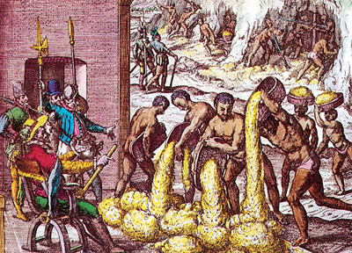 | Briefly explain the labor and land ownership system established by the Spanish encomienda system.

An Account of the Pueblo Revolt
(Popé’s Rebellion)
by Don Antonio de Otermin, Governor and Captain-General of New Mexico
September 8, 1680

I received information that a plot for a general uprising of the… Indians was being formed and was spreading rapidly. This was wholly contrary to the existing peace and tranquility in this miserable kingdom, not only among the Spaniards and natives, but even on the part of the heathen enemy, for it had been a long time since they had done us any considerable damage… [But] the situation of this kingdom… makes it so easy for the [Indian] rebels to carry out their evil designs, for it is entirely composed of estancias, quite distant from one another.

On Tuesday, the 13th of the said month, at about nine o'clock in the morning, there came in sight of us… all the Indians of the Tanos and Pecos nations and the Queres of San Marcos, armed and giving war whoops. As I learned that one of the Indians who was leading them was from the villa and had gone to join them shortly before, I sent some soldiers to summon him… Upon receiving this message he came to where I was, and… I asked him how it was that he had gone crazy too – being an Indian who spoke our language, was so intelligent, and had lived all his life in the villa among the Spaniards, where I had placed such confidence in him – and was now coming as a leader of the Indian rebels. He replied to me that they had elected him as their captain, and that they were carrying two banners, one white and the other red, and that the white one signified peace and the red one war. Thus if we wished to choose the white it must be upon our agreeing to leave the country, and if we chose the red, we must perish, because the rebels were numerous and we were very few…

On hearing this reply, I spoke to him very persuasively, to the effect that he and the rest of his followers were Catholic Christians, asking how they expected to live without the religious; and said that even though they had committed so many atrocities, still there was a remedy, for if they would return to obedience to his Majesty they would be pardoned; and that thus he should go back to this people and tell them in my name all that had been said to him, and persuade them… He came back from them after a short time, saying that his people asked that all classes of Indians who were… our [captives] be given up to them… He demanded also that his wife and children be given up to him… If these things were not done they would declare war immediately…

I told him (having given him all the preceding admonitions as a Christian and a Catholic) to return to his people and say to them that unless they immediately desisted from sacking the houses and dispersed, I would send to drive them away from there. Whereupon he went back, and his people received him with peals of bells and trumpets, giving loud shouts in sign of war.

With this, seeing after a short time that they not only did not cease the pillage but were advancing toward the villa with shamelessness and mockery, I ordered all the soldiers to go out and attack them until they succeeded in dislodging them from that place. Advancing for this purpose, they joined battle, killing some at the first encounter. Finding themselves repulsed, they took shelter and fortified themselves in the said hermitage and houses of the Mexicans, from which they defended themselves a part of the day with the firearms that they had and with arrows…

On the morning of the following day, Wednesday, I saw the enemy come down all together from the sierra where they had slept, toward the villa. Mounting my horse, I went out with the few forces that I had to meet them, above the convent. The enemy saw me and halted, making ready to resist the attack. They took up a better position…

The next day, Thursday… there were only some light skirmishes… I knew well enough that these dilatory tactics were to give time for the people of the other nations who were missing to join them in order to besiege and attempt to destroy us…

On the next day, Friday, the nations of the Taos, Pecuries, Jemez, and Queres having assembled during the past night, when dawn came more than 2,500 Indians fell upon us in the villa, fortifying and intrenching themselves in all its houses and at the entrances of all the streets, and cutting off our water... They burned the holy temple and many houses in the villa. We had several skirmishes over possession of the water, but, seeing that it was impossible to hold even this against them, and almost all the soldiers of the post being already wounded, I endeavored to fortify myself in the casas reales and to make a defense without leaving their walls…

On the next day, Saturday, they began at dawn to press us harder,… saying to us that now we should not escape them, and that, besides their own numbers, they were expecting help from the Apaches whom they had already summoned… Indian rebels… burn[ed] all the houses of the villa, and they kept us in this position the entire night… What grieved us most were the dreadful flames from the church and the scoffing and ridicule which the wretched and miserable Indian rebels made of the sacred things…

Finding myself in this state… I determined to take the resolution of going out in the morning to fight with the enemy until dying or conquering… [A]ll of us who could mounted our horses, and the rest went on foot with their arquebuses… On coming out of the entrance to the street it was seen that there was a great number of Indians. They were attacked in force, and though they resisted the first charge bravely, finally they were put to flight, many of them being overtaken and killed. Then turning at once upon those who were in the streets leading to the convent, they also were put to flight with little resistance…

Finding myself a little relieved by this miraculous event, although I had lost much blood from two arrow wounds which I had received in the face and from a remarkable gunshot wound in the chest on the day before… and [b]ecause we now found ourselves with very few provisions for so many people… I set out for La Isleta, where I judged [my] comrades… would be…

Source: Translation from C. W. Hackett, ed., Historical Documents relating to New Mexico, Nueva Vizcaya, and Approaches Thereto, to 1773, vol. III [Washington: Carnegie Institution of Washington, 1937] pp. 327-35.
What factors allowed the Indians to achieve early victories?

What factors allowed the Spanish to triumph in the end?

Why do you think that Spanish policy toward the Indians became somewhat more tolerant and inclusive after the Pueblo Revolt?

Cultural Change & Continuity
Briefly explain the degree to which colonization of the Americas changed or allowed for the continuity of these cultures in the 1500s and 1600s. Write at least one sentence in each column.

Spanish/Portuguese |  | Indigenous |  | African
Change | Continuity | Change | Continuity | Change | Continuity

“The Black Legend”
The “Black Legend” is the idea that the Spanish were unparalleled by other Europeans in their cruelty toward indigenous Americans and that the Spanish showed no willingness to integrate Indian culture with their own culture.

In a paragraph response, defend or critique the concept of the “Black Legend,” citing at least three pieces of evidence.

Environmental Impact
Briefly explain the environmental impact on the Americas of:

Native American “three-sister” farming   | European monoculture farming  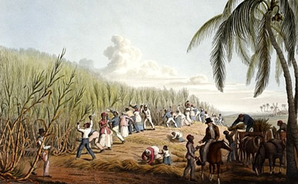
Introduction of new European animals during the Columbian Exchange   | Mining of Precious Metals  